Meat&More is a fast-growing company in the food industry specialising in meat and ready-to-eat products. Meat&More works end-to-end and is active from production to retail-sales. They have two commercial channels:

* **Buurtslagers**which provides retailers such as Smatch, Carrefour, Lidl and Delhaize with a meat and ready-to-eat offering within their stores
* **Bon'Ap**, a Meat&More store concept, offering various meat and ready-to-eat products including but not limited to meat.

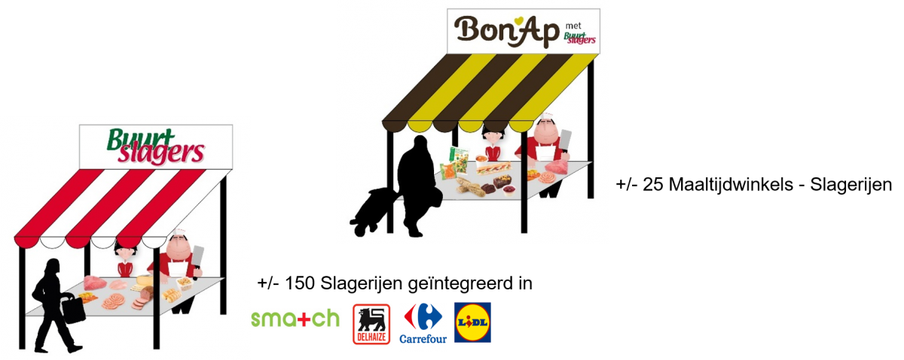

## **Challenge**

With thousands of products and hundreds of stores, Meat&More set up a Supply Chain 2020 program aimed at making sure **the right product is in the right quantity in the right store**. Not only would this support financial return through less food waste, time saved and recovery of lost sales but this would strengthen client satisfaction as well through less stock-outs, increased freshness and environmental responsability.

The objective was to go from a pull-model to a push model:

* In the existing**pull-model** orders are made just-in-time by the store responsible, made or picked-to-order and shipped to the stores
* In a smart**push-model**expected quantities are forecasted ahead for all products and stores, production is optimally planned and products are delivered (i.e. pushed) based on this forecast.   
  If the forecast can smartly take into account weather, seasonality, price-sensitiveness, promotions and past sales, this push-model can result in high level of automation, optimized Supply Chain planning and better execution of 'the right product is in the right quantity in the right store'

Meat&More is a fast-growing company in the food industry specialising in meat and ready-to-eat products. Meat&More works end-to-end and is active from production to retail-sales. They have two commercial channels:

Buurtslagers which provides retailers such as Smatch, Carrefour, Lidl and Delhaize with a meat and ready-to-eat offering within their stores

Bon’Ap, a Meat&More store concept, offering various meat and ready-to-eat products including but not limited to meat.

Using AI-Demand Forecasting to drive Supply Chain Planning

Challenge

With thousands of products and hundreds of stores, Meat&More set up a Supply Chain 2020 program aimed at making sure the right product is in the right quantity in the right store. Not only would this support financial return through less food waste, time saved and recovery of lost sales but this would strengthen client satisfaction as well through less stock-outs, increased freshness and environmental responsability.

The objective was to go from a pull-model to a push model:

In the existing pull-model orders are made just-in-time by the store responsible, made or picked-to-order and shipped to the stores

In a smart push-model expected quantities are forecasted ahead for all products and stores, production is optimally planned and products are delivered (i.e. pushed) based on this forecast.

If the forecast can smartly take into account weather, seasonality, price-sensitiveness, promotions and past sales, this push-model can result in high level of automation, optimized Supply Chain planning and better execution of ‘the right produc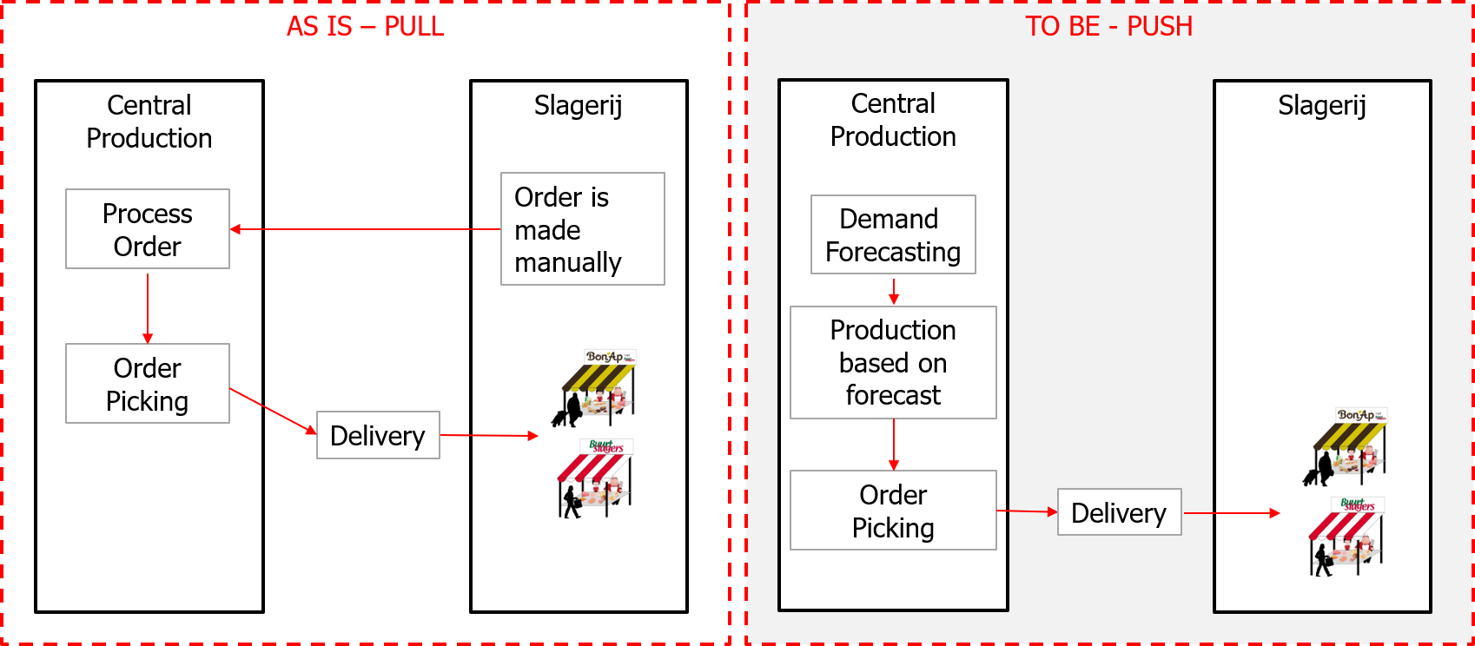t is in the right quantity in the right store’

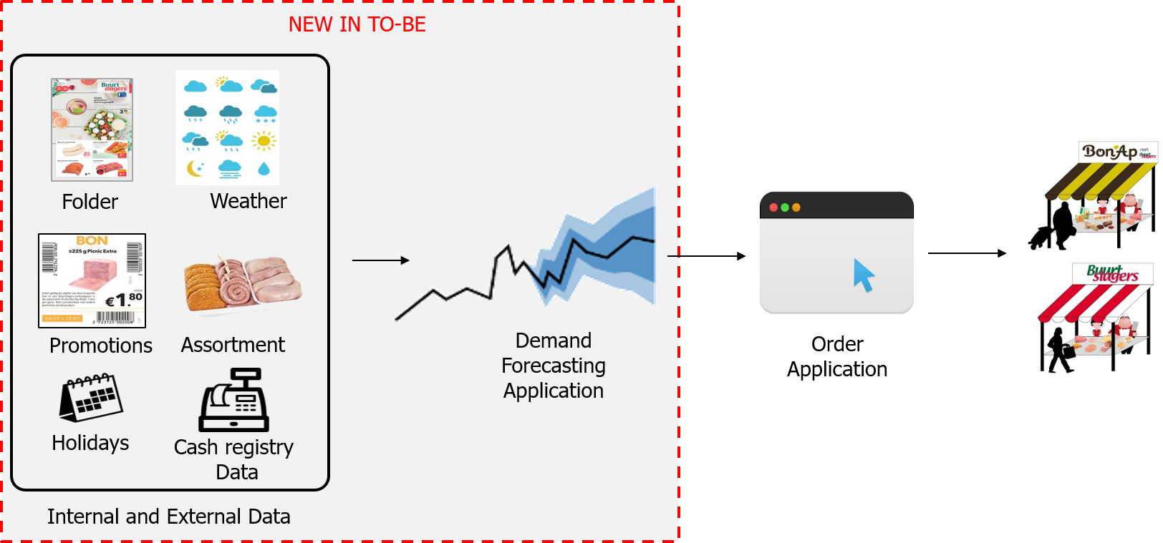Internal and External data is used for the AI forecast

In moving from a pull-model to a push-model, it was important for Meat&More and store responsibles to **have transparency in the AI algorithm**: "what is driving this forecast and why is it forecasting X.". To provide this transparency it was chosen not to work with deep learning but rather to work, in this phase, with simpler yet performant AI techniques.

The demand forecasting was a not a typical time-series set-up. Although trends and seasonality play a role, the importance of drivers such a promotions and weather change suggested in using a driver-based regression approach. **Best accuracy was realised with using a RandomForestRegressor** with hyperparameter tuning and attention of removing outliers from the baseline. The accuracy realised varied per product but the overall success figure was <5% error on 60% of tested products on a cross-validated test period (i.e. RMSE divided by mean error).

The result is an AI algorithm which runs daily for every product and store and forecasts quantities up to 14 days ahead. The long-term forecast (14 days) is used for MRP & purchasing and the short-term forecast (i.e., sales for tomorrow) is used for store replenishment and delivery.

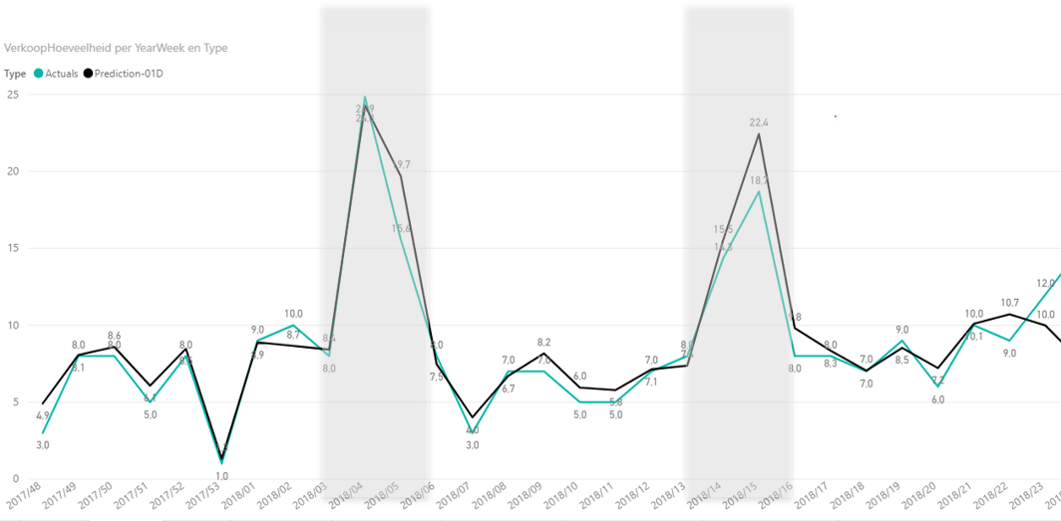

The solution for scalability: a Hybrid Data Platform using Microsoft Azure

The algorithm needs data and needs compute power to run. To allow for scalability and flexibility, Meat&More decided to complement their existing BI set-up with a Data Platform in the Microsoft Azure Cloud.

Using an on-premise gateway, various datasets including transactional sales data, promotion data and weather are ingested daily into the Azure Data Lake (Blob Storage) using Azure Data Factory. Once loaded, the scheduling tool Airflow triggers the forecasting cycle where a cluster of computing nodes (up to 200 VMs) in Azure Batch are launched in parallel to train (once per week) and score (every day) the demand forecasting application.

The Data Platform supports the use of open-source tooling such as R and Spark to allow any new AI techniques in the future to be absorbed as quickly as possible. Microsoft Azure Cloud enabled this open-source focus through services such as Azure Container Registry and Azure Batch whereas by using Docker technology we had full flexibility in embedding our AI algorithm in a open-source set-up configured with best-practices.